Contents
Requirement Document for Patient Level ART Dashboard and DQI&U Line List Final Changes 2
Part One: Client on ART Data Completeness and Missed Clinical Opportunities View Page 2
Introduction 2
Rationale 2
Scope 2
Detail Description of the Patient level ART Dashboard 2
Contents 2
Patient ART Dashboard Template (Search Home Page) 5
Search Home Page (Currently Blank) 6
Part Two: Last Changes to the Data Quality and Use Line List 7
Remaining Taks to the Implemented Data Quality and Use Line List 7
Columns to be added in Data Quality and Use Line List 7
Final Status Labelings to implement in Data Quality and Use Line List 8

Requirement Document for Patient Level ART Dashboard and DQI&U Line List Final Changes

Part One: Client on ART Data Completeness and Missed Clinical Opportunities View Page

Introduction
The Ethiohri client level search should be used to help system users/clinicians to identify all the data completeness and missed clinical opportunities based on what has already been documented in the clinical follow-up details.
As all clinical follow-up details, data quality level and missed clinical opportunities are difficult to trace there should be a view page that could help users easily identify the data completeness level and missed clinical opportunities in single page prepared in form of dashboard to be inserted at the patient level search in the clinical visits page.

Rationale
Simplify the data access and enhance the clinician’s capacity and use practice by creating a single page showing the clinical details in a usable context that can be used for patient level decision making.
The current data quality and data use practices by clinicians at service delivery level stayed limited due to the right data access issues that can be solved by creating a simplified and usable patient level interpretable data view at their fingertips at point of service delivery.

Scope
This dashboard will encompass only for clients on ART care, which holds more than 90% of the HIV data management process practiced by the Ethiohri system.

Detail Description of the Patient level ART Dashboard

Expectations
- The data in the patient dashboard is expected to reflect the situation of the patient at current date (TODAY).
- Content better be one to two pages length
- Better to have a print preview capability

Contents
- Patient Registration Information
  - Full Name
  - Age and BOD
  - Sex
  - MRN
  - UAN
  - PHRH Code
  - NCD Code
  - ICD #
- ART Enrollment Information
  - Registration Date
  - HIV Confirmed Date
  - ART Start Date + Months on ART
  - TI Date
- Client Address
  - Region
  - Zone/Sub-City
  - Woreda
  - Kebele
  - House Number
  - Mobile Phone Number
  - Address Completeness Status as GREEN/YELLOW
- Previous ART Visit Status
  - Follow-Up Date
  - Follow-Up Status
  - ARV Regimen
  - ARV Regimen Dose
  - TX_Curr End Date
  - Nutritional Status
  - Pregnancy Status (only for females)
Note: Pregnancy Status from recent (last follow-up)
  - ___ PMTCT Status: ___ as Currently on PMTCT
Note:
- Currently on PMTCT: client has documented PMTCT Start Date but No Discharge Date
- Not Applicable: All other clients
  - Modern Family Planning Method:
Note: family planning method from the recent (last follow-up)
  - Next Visit Date + _____ Missed Days ____ (from today)
- Viral Load Status
  - Viral Load Status as:
    - Viral Load Done (Currently not Eligible)
    - Eligible for Viral Load Test
    - Not Applicable
    - ART Not Started
  - Viral Load Eligibility Date: the next date the client is expected to have a viral load test result available
- Tuberculosis Preventive Therapy (TPT) Info
  - Gold
  - Silver
  - Bronze: classify all Bronzes (1-6) under this category for simplicity of use and reduce complexity
  - Contraindicated for TPT
  - On TB Treatment
  - ART Not Started
- TB Treatment Info
  - Active TB Diagnosis Date
  - TB Treatment Start Date
  - TB Treatment Discontinued Date
  - TB Treatment Completed Date
- Current DSD Category
- ICT Screening Status
- NCD Screening Status
- Cervical Cancer Screening & RX Status (Only for females >=25 at current date)
- Target Population Category: PWID

Patient ART Dashboard Template (Search Home Page)
Note:
- To be included in the patient search page only for clients with HIV Confirmed Date
- is not required for other clients (PrEP, PostEP)
ART CLIENT SUMMARY INFORMATION
Patient Registration | Semira Ahmed Kemal
 | Sex: Female
 | DOB: 27/02/1977 Age: 40
 | MRN: 901920 UAN: 14/09/016/01451
 | PHRH Code: 98298 NCD Code: 6748 ICD #: 652637
ART Enrollment | Registration Date: 09/12/2012
 | HIV Confirmed Date: 09/12/2012
 | ART Start Date: 09/12/2012
 | Transfer-In Date: 02/30/2017
Client Address | Region: Addis Ababa Zone/Sub-City: Addis Ketema
 | Woreda: 14 Kebele: 14 House #: New
 | Mobile Phone Number: 0999999999
 | Address Completeness Status: GREEN
Previous ART Visit | Follow-Up Date: 08/03/2017
 | Follow-Up Status: Alive on ART
 | ARV Regimen: 1J ARV Regimen Dose: 90
 | TX_Curr End Date: 08/07/2017
 | Next Visit Date: 08/06/2017 Missed Days: 30
 | Nutritional Status: Sever Malnutrition
 | Pregnancy Status: No PMTCT Status: Not Applicable
 | Modern Family Planning Method: Oral Contraceptive Pill
Viral Load | Status: Viral Load Done (Currently Not Eligible)
 | Viral Load Eligibility Date: 08/03/2018
Tuberculosis Preventive Therapy (TPT) | Status: Gold (TPT Completed)
TB Treatment | Active TB Diagnosis Date: 02/09/2012
 | TB Treatment Start Date: 02/09/2012
 | TB Treatment Discontinued Date: ------
 | TB Treatment Completed Date: 02/04/2013
Current DSD | Current Category: 3MMD
ICT Screening | Status: Currently Eligible for Rescreening
NCD Screening | Status: Not Screened
 | Next NCD Screening Date: TODAY
Target Population Category (PHRH) | People Who Inject Drug (PWID)

Search Home Page (Currently Blank)
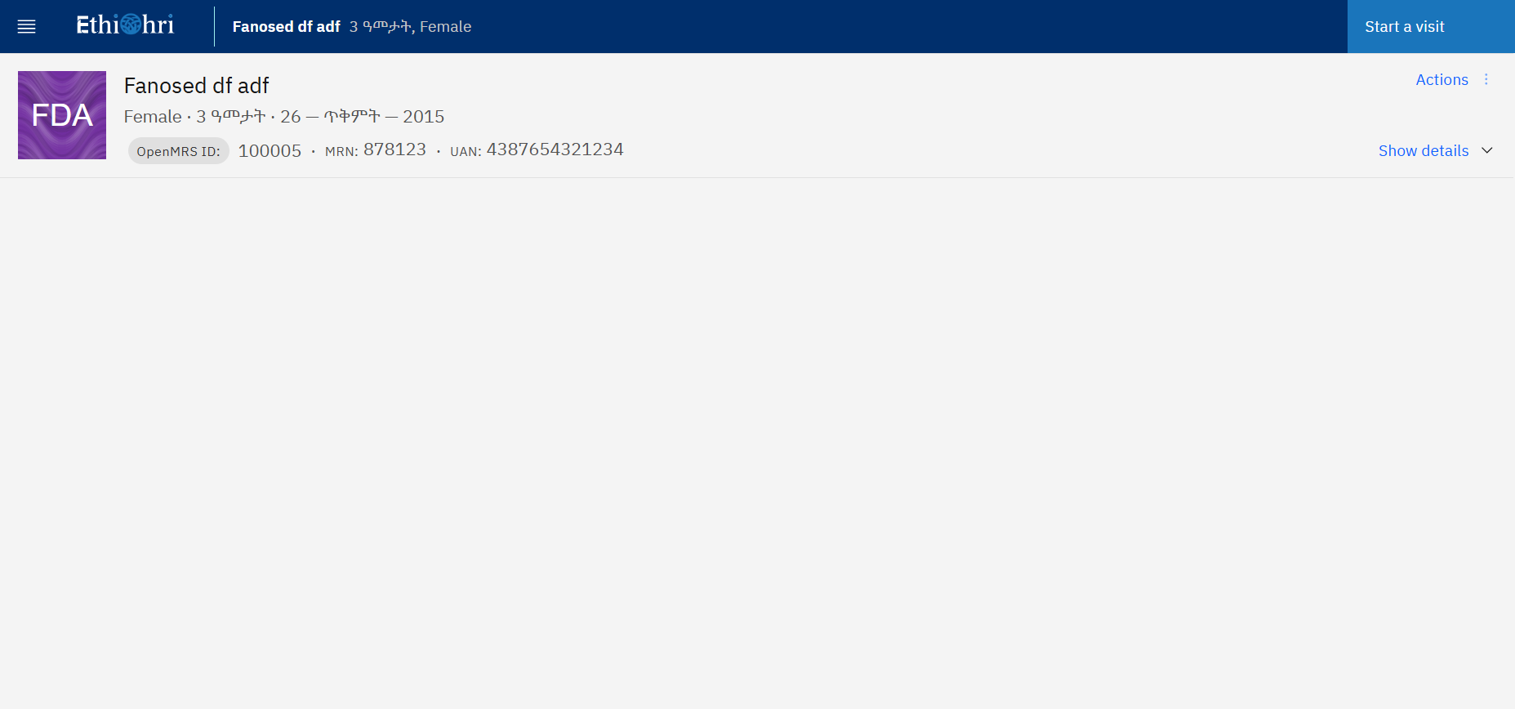

Part Two: Last Changes to Data Quality and Use Line List

Remaining Taks to the Implemented Data Quality and Use Line List
- Render ART Not Started Status for the Following Status Columns
  - Cervical Cancer Screening & Rx Status
  - Viral Load Status
  - NCD Status
  - ICT Screening Status
- For TPT Status
  - Check the Uncategorized Clients
  - Check status labeling for “Contraindicated for TPT” for clients “Reason for not being eligible for TPT” document as Contraindication in the latest follow-up
  - Check Bronze 5,
    - Which should show clients TB Treatment Completed Date > 3 years from the current reporting end date (report generated date)
    - But status currently not working
  - Check ART Not Started status labeling
- Correct the Following Cervical Cancer Screening & RX Status Labeling
  - Green as Previously Screened (Green)
  - Yellow as Eligible for Cervical Cancer Screening/RX (Yellow)
  - Red as Red as Red (Confirmed Cervical Cancer)
  - Black as ART Not Started (Black)
  - Blue as Not Applicable (Blue)
  - White as Not Eligible (White)

Columns to be added in Data Quality and Use Line List
- Reporting Date (EC):
    - Is the date user entered for report generation in Ethiopian Calendar, Like Tikimt 20, 2028, then the date will displayed as 02/20/2018 E.C.
    - It is used to give time stamps to the data generated for analysis for performance comparison and trend analysis
- Reporting Date (GC): the report generation date in Gregorian calendar, like 10/30/2025 G.C.
- Active TB Diagnosis Date (GC + EC)
- TB Treatment Start Date (GC + EC)
- TB Treatment Discontinued Date (GC + EC)
- TB Treatment Completed Date (GC + EC)
- TPT Start Date (GC + EC)
- TPT Discontinued Date (GC + EC)
- TPT Completed Date (GC + EC)
- Pregnancy Status (yes/no)
- Breast Feeding Status (yes/no)
- Modern Family Planning Used
- Disclosure Stage (DS0-3)
- PMTCT Booking Date (GC + EC)
- PMTCT Discharge Date (GC + EC)
- Viral Load Sent Date (GC + EC)
- Viral Load received Date (GC + EC)
- WHO Stage
- CD4 Test Result
- VISITECT CD4 Result
- TI Date (GC + EC)

Note: all the above columns when added should be critically checked with respect to the date entered by users (reporting date) and all values should be only what has been documented before or at the time of the reporting end date.

Final Status Labeling to implement in Data Quality and Use Line List
The following Statuses will be available at the end of the Ethiohri 2.0 Development Phase
- Column Name: TB Treatment (RX) Status
  - LABEL:
  - Active TB Diagnosed & No RX

Rules
- Active TB DX Date
- No TB Treatment Start & Complete Date

  - On TB Treatment

Rules
- Active TB DX Date
- TB Treatment Star Date-TODAY <2 years
- No TB Treatment Complete Date

  - Unknown TB Treatment Completion

Rules
- Active TB DX Date
- TB Treatment Star Date-TODAY >=2 years
- No TB Treatment Complete Date

  - Completed TB Treatment
Rules
- Active TB DX Date
- TB Treatment Complete Date Documented

- Column Name: PMTCT Enrollment Status
  - Label:
- Currently on PMTCT

Rules
- Client having Booking Date <= TODAY (Reporting End Date)
- But No PMTCT Discharge Date Documented which is LESS THAN OR EQUAL TO THE REPORTING END DATE (report date requested

- Enrolled & Currently Discharged

Rules
- Client is having Booking Date <= TODAY (Reporting end date) AND PMTCT Discharge Date also documented
- But the PMTCT Discharge Date should be less than or EQUAL to TODAY (reporting end date) entered by system users

- Column Name: Disclosure Stage

  - Label: DS0-DS3

Rules
- DS0: client having DS0 documented in the follow-up date <= current date (Reporting end date)
- DS1: client having DS0 documented in the follow-up date <= current date (Reporting end date)
- DS2: client having DS0 documented in the follow-up date <= current date (Reporting end date)
- DS3: client having DS0 documented in the follow-up date <= current date (Reporting end date)

- Column Name: Advanced HIV Disease

  - Label: Yes/No

Rule: Use Previous Rules
- Column Name: Target Population Category (PHRH)
  - Label:
- FSW
- PWID (People Who Inject Drug)
- High Risk AYGW (Adolescent Girls and Young Women)
- OTHER PHRH
- NOT KEY & PRIORITY POPULATION (GENERAL POPULATION)

Rule: See the documentation “People at High Risk of HIV (PHRH) Reports_FINAL_111825”

- Column Name: NCD Screening Eligibility Status

  - Label: assign the following rules for each client in DQ & Use Line List based on Stated Rules

- Not Screened
- Needs Rescreening Normal BP
- Confirmed HTN
- Needs Rescreening Normal BG (<=50 Yrs)
- Needs Rescreening Normal BG (>50 Yrs)
- Need Rescreening Prediabetes
- Confirmed DM
- Confirmed DM & HTN
- Not Applicable

- Column Name: NCD Screening Eligibility Date

  - Label: Calculated date for each client based on rule stated

- Column Name: Reason for NCD Screening Eligibility

  - Label: assign reason for eligibility to eligible clients ONLY based on rule stated. All not eligible will have NOT APPLICABLE as a reason.

Rule: See the documentation (EXCEL DOC) “NCD Screening & PHRH Line Lists_111825”

